Database (SQL) - (Abanoub Refaat)

Giving the following databases, you can download the SQL file from here:

<http://careers.izam.co/online-test/store_test.sql>

**products**

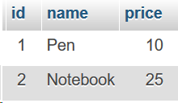

**stock_transactions**

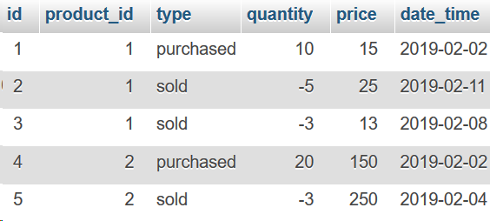

**Write the following Queries:**

**Q1-** a query that lists all products (name and the current stock quantity) for each, the current stock is calculated by summing the negative and positive “Quantity” field in the “stock_transactions” table.

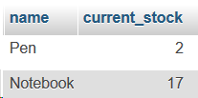

**Q2-** a query that gets the total sold and total purchased quantities from each item.

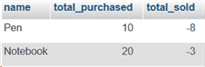

**Q3-** The average sold price for each item.

-------------

Backend Coding:  
  
Q4- Write a function that takes a two-dimensional array and returns a one-dimensional array containing the unique values of each array (Without using the **array_merge**  function on PHP).

**I.e. input will be:**

[ 0 => [0=>’a’ , 1=>’b’ , 2=>’c’ ] ,

1 => [0=>’x’ , 1=>’b’ , 2=>’a’],

2=> [0=>’z’ , 1=>’z’ , 2=>’v’] ]

**Output should be:**

[a,b,c,x,z,v]

----

**Q5-** Write PHP code that **searches** in a **sorted** array, without calling any built-in functions.  
**Note: Please use an algorithm that achieves the shortest run-time**

* The function will get a sorted array and the needle element value.
* The function will return the key of the item if it is found, or false if it is not.

---

**Q6-** Write PHP function that takes an HTML tag as string and returns its ID value if existed or false if it has no ID

example: When calling

getTagID('<div id="container">');

it will return the string:

"container"

------

**Q7-** Write a function that takes a two-dimensional array and rotates each ROW for 0,1,2 ..etc times, so it will shift the first row 0 times to the right, the second row will be shifted 1 time, the third will be shifted three times.. For example

If it got this array

| A | D | F |
| --- | --- | --- |
| K | N | P |
| R | S | V |
| X | Y | Z |

It will return the following:

| A | D | F |
| --- | --- | --- |
| P | K | N |
| S | V | R |
| X | Y | Z |

-----

Javascript:

Open the following HTML page, open the browser console and write a javascript code that does the following (copy and paste the code to answer):

<http://careers.izam.co/online-test/jstest.html>

**Q8-** Swaps the second and third columns in the table.

**Q9-** Validate the form as follows:

* “**Method**” Input must be required before submitting the form.
* If the user selected the “**Email**” for Method, the “**Phone**” input should disappear, and he must enter the email address before submitting the form.
* If the user selected “**Phone**” for Method, the “**Email Address**” input should disappear, and he must enter the phone before he submits the form.
* After submitting the form, the submitted values should automatically fill the form by code, and the above rules should be applied.